Extending the Renewable-Resource Fishery Model
Consumer Substitution as a Second Balancing Loop on a Market-Driven Resource Industry
System Dynamics Group Assignment — Revised Report

1. Chosen Baseline Model
We extend the Renewable-Resource-Constrained Capital model from Chapter 2 of Thinking in Systems (Fig. 42), illustrated with a fishery. The model couples two stocks:
- Capital (fishing fleet) — grows through a reinforcing investment loop: more Capital → more Harvest → more Profit → more Investment → more Capital.
- Resource (fish population) — depleted by Harvest and replenished by Regeneration; constrained by a balancing loop: more Capital → more Harvest → less Resource → lower Yield Per Unit Capital → lower Profit → less Investment → less Capital growth.
Depending on the relative strength of the reinforcing investment loop and the resource-depletion balancing loop, the textbook shows three qualitative outcomes for this baseline structure: smooth adjustment to equilibrium (Fig. 43), overshoot and oscillation (Fig. 44), or overshoot and collapse (Fig. 45).

2. Limitations of the Baseline Model
As presented in the textbook, the baseline model treats fish Price as fixed and assumes the only thing that can slow the industry down is the fishery's own resource base. It has no mechanism for demand-side behavior. This creates several blind spots:
- It cannot represent consumers switching to a substitute good (e.g., chicken) as fish becomes scarce and expensive — there is no channel through which price feeds back into demand.
- It cannot distinguish between an industry that is stabilized purely by physical resource limits versus one that is also disciplined by market forces outside the fishery itself.
- It treats the reinvestment growth goal as the only thing worth varying — it can't tell us whether an external, non-resource mechanism (a substitute market) would change which of Meadows' three outcomes (equilibrium, oscillation, collapse) occurs at a given growth goal.
Example questions the baseline model cannot answer:
- If consumers can substitute away from an increasingly expensive resource, does that soften boom-and-bust cycles in the resource industry, or is it too weak/slow to matter?
- Does a market-level substitution effect change which growth goals lead to smooth equilibrium versus oscillation versus collapse?
- Can a market-driven resource industry expand endlessly, or will dynamic resource limits and consumer substitution force it into a stable equilibrium?

3. Question We Chose to Investigate
“Can a market-driven resource industry expand endlessly, or will dynamic resource limits and consumer substitution force it into a stable equilibrium?”

4. Our Extended Model
We coupled the fishery model with a minimal substitute-good market (chicken), following the “couple models” path. This adds exactly one stock — Chicken Meat Stock — keeping us within the one-extra-stock complexity budget.
- Chicken Meat Stock (new stock): produced and consumed at a base rate, roughly self-balancing.
- Chicken Demand Ratio (new converter): a graphical function of fish Price, rising from 0 to 1 as Price rises from 0 to 3. It represents the fraction of would-be fish demand that shifts to chicken as fish gets pricier.
- Modified Harvest equation: Harvest = Capital × Yield Per Unit Capital × (1 − Chicken Demand Ratio). As Chicken Demand Ratio rises, realized Harvest is throttled back even if Capital and Yield Per Unit Capital haven't changed.
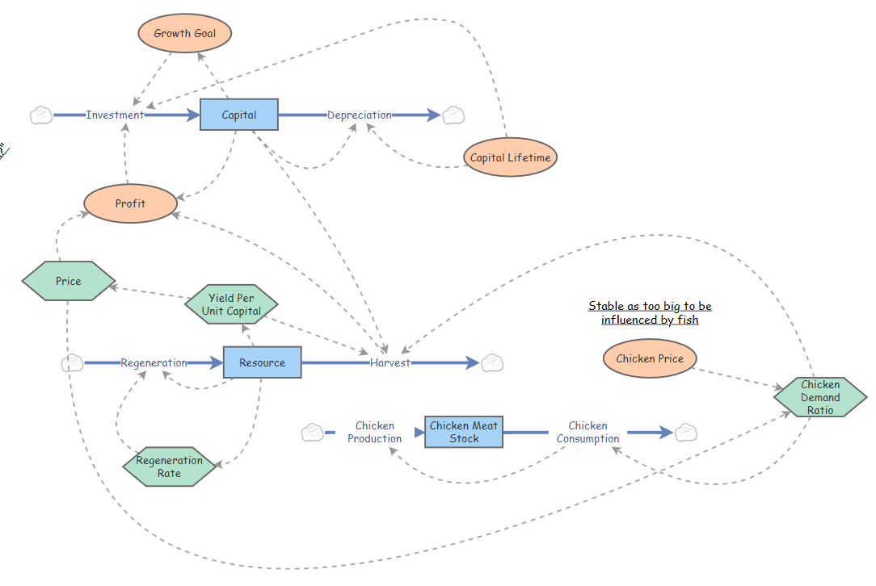Figure 1. Stock-and-flow diagram. The core fishery loops (top/left) follow Meadows’ Fig. 42. The added structure (right) is the chicken sub-market: Chicken Production and Consumption keep Chicken Meat Stock roughly steady, while Chicken Demand Ratio — driven by fish Price — feeds back into the Harvest equation.

5. Why We Extended It This Way
In Step 1 of the assignment we looked for constants that are secretly another model's stock. Price, in the baseline fishery model, is treated as an isolated, self-contained number — but in the real world, how much consumers actually respond to a price increase depends on whether a viable substitute exists (a stock of chicken meat that can be produced and bought). Coupling the fishery to a tiny substitute-good market lets that hidden driver enter the model explicitly, at the cost of only one additional stock and one additional converter — the smallest structural change that lets us ask whether market-level substitution behaves like a second balancing loop.

6. Our Hypothesis
We expected the chicken-substitution mechanism to act as a second, market-based balancing loop layered on top of the resource-depletion loop. Our prediction was that this second loop would reliably push the system toward smooth convergence — i.e., that adding consumer substitution would make the fishery settle into a stable equilibrium rather than oscillate or collapse, more or less regardless of how aggressive the industry's reinvestment growth goal was.

7. Results: Simulation Runs
We ran the extended model at three growth-goal settings (a parameter push) and one run in which Profit itself was overridden to a fixed exogenous value rather than being computed from Harvest and Price (a structural change that disables the resource-depletion loop's grip on Investment).

7.1 Growth Goal = 0.01 (very conservative reinvestment)
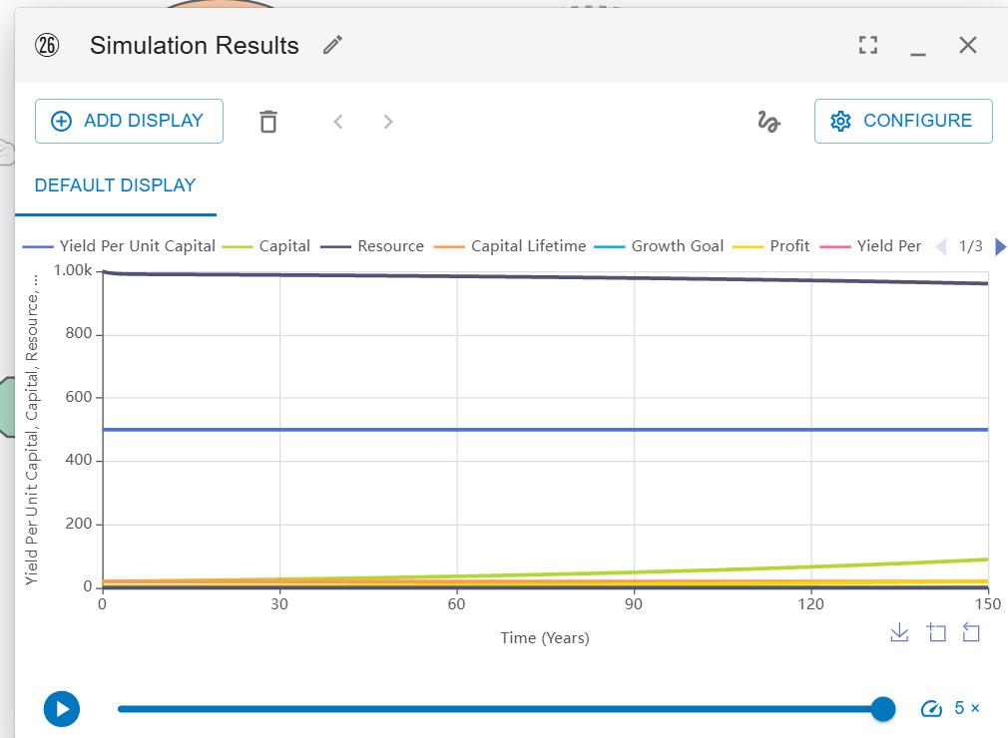
Figure 2. Growth Goal = 0.01, Chicken Price = 3, Capital Lifetime = 20.
At this very low growth goal, Capital barely grows over the full 150-year run (rising from about 10 to under 100), and Resource stays close to its starting value of 1000 throughout. The reinforcing investment loop is so weak that the industry never grows large enough to meaningfully stress the resource — neither the resource-depletion loop nor the chicken-substitution loop is ever really put to the test. This is a degenerate, uninteresting equilibrium: stable only because nothing much happens.

7.2 Growth Goal = 0.05 (baseline reinvestment target)
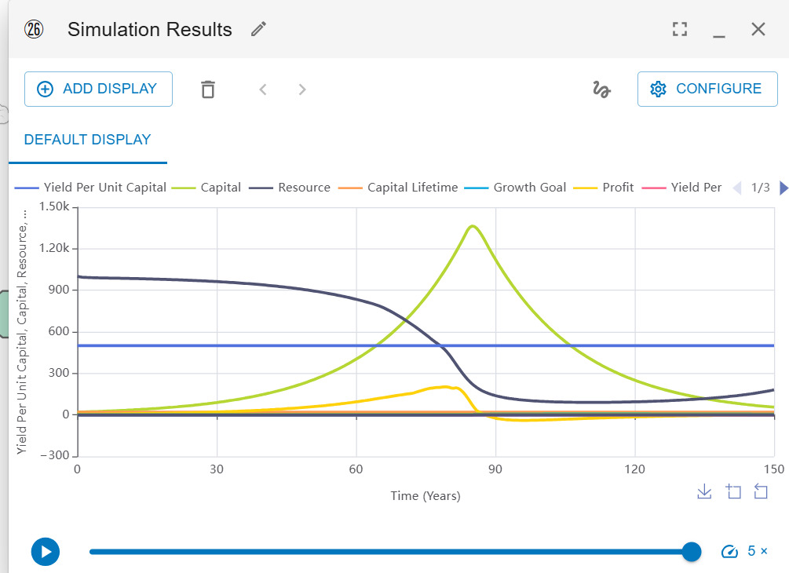
Figure 3. Growth Goal = 0.05, Chicken Price = 3, Capital Lifetime = 20.
Here Capital rises and overshoots to a peak of roughly 1,300 around year 80, then declines to about 600 by year 150. Resource falls from 1000 down toward roughly 250–300 by year 90 and stays low. Profit climbs to a peak near 580 around year 80 and then falls back toward zero. This is an overshoot-and-partial-decline pattern, not the smooth convergence we had predicted: the substitution loop slows the ascent of Capital somewhat, but it does not prevent overshoot, because fish Price does not rise far or fast enough, early enough, to divert enough demand before Capital has already overbuilt.

7.3 Growth Goal = 0.15 (aggressive reinvestment)
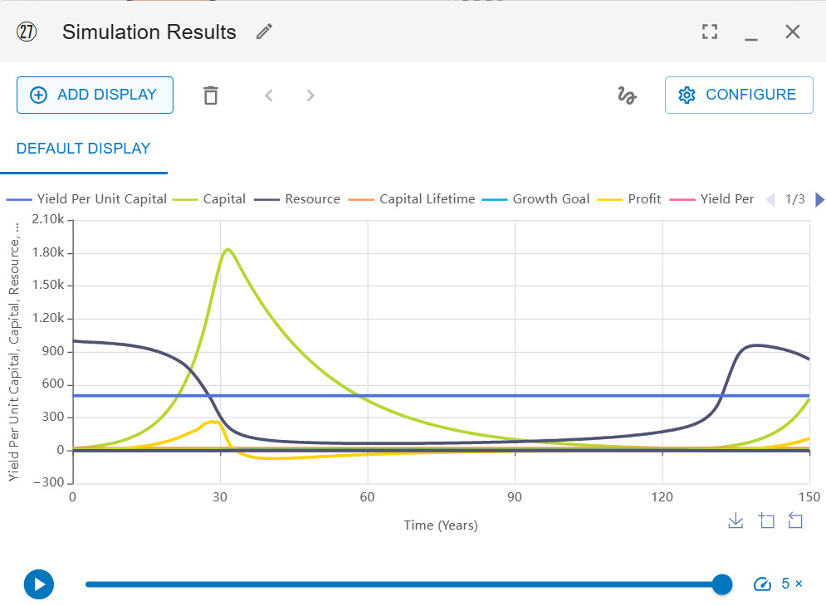
Figure 4. Growth Goal = 0.15, Chicken Price = 3, Capital Lifetime = 20.
Pushing the growth goal further produces a much sharper overshoot: Capital shoots up to roughly 1,800 by year 30, then collapses toward zero by around year 90–100 alongside the Resource. Around year 130–140, a second growth cycle begins as Resource starts to recover and Capital creeps back up; a boom-bust-rebound pattern. This matches the oscillation/overshoot-and-collapse behavior Meadows illustrates in Figures 44–45, not the smooth adjustment of Figure 43. Pushing the growth-goal parameter harder made the system less stable, not more.

7.4 Structural Change: Profit Fixed at an Exogenous Value (65), Growth Goal = 0.05
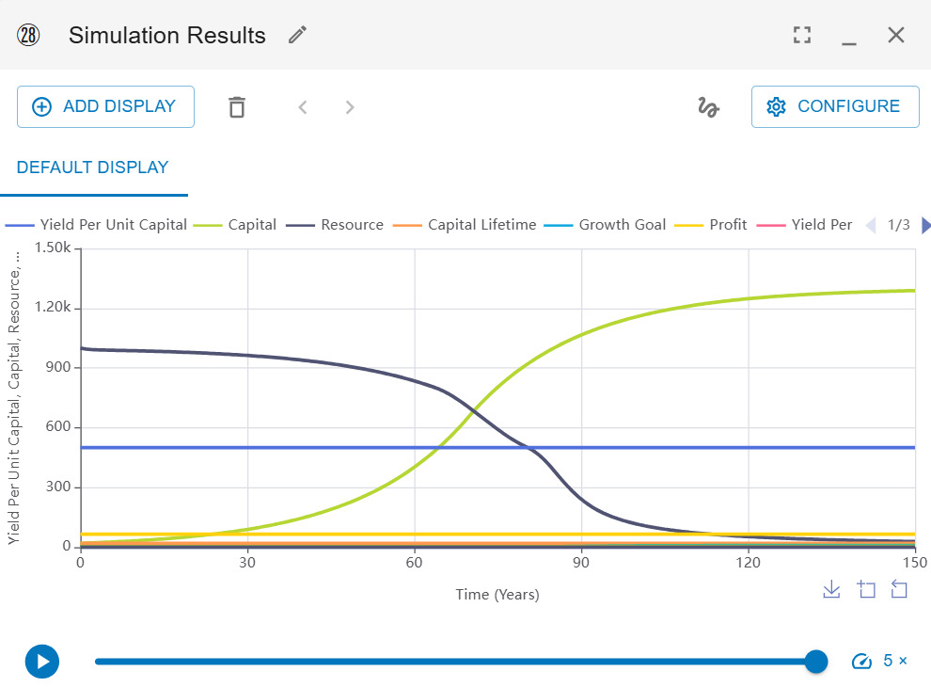
Figure 5. Growth Goal = 0.05, Profit overridden to a fixed value of 65 instead of being computed from Harvest × Price − cost. Compare directly to Figure 3, which uses identical Growth Goal but computed Profit.
Rather than pushing a parameter, this run changes the model's structure: Profit is decoupled from Harvest and Price and held at a constant, which severs the resource-depletion loop's grip on Investment. With Investment no longer starved as fish get scarce, Capital rises smoothly in an S-curve to roughly 1,300–1,350, while Resource declines smoothly and steadily all the way down toward zero by around year 100–110 — no oscillation at all. The system does converge cleanly, but only because we disabled the very feedback (profit falling as the resource is depleted) that is supposed to protect the resource. The smooth curve conceals a fishery that has been driven to near-exhaustion.

8. Insights and Answers
Our results did not match our hypothesis. We expected the chicken-substitution loop to reliably stabilize the system across growth goals; instead:
- Growth Goal, not the substitution loop, is the dominant lever for whether the system oscillates. At a very low growth goal the industry never grows enough to matter (Fig. 2); at the baseline and high growth goals, overshoot appears and gets worse as growth goal rises (Figs. 3–4).
- The substitution loop is real but weak and delayed: Chicken Demand Ratio only responds to fish Price, and Price itself only rises after Yield Per Unit Capital (and therefore Resource) has already fallen. By the time the substitution signal is strong enough to throttle Harvest meaningfully, Capital has typically already overbuilt — so the loop softens the overshoot slightly but does not prevent it.
- The structural-change run (fixing Profit) shows a different, more troubling route to a “smooth” curve: remove the resource-depletion loop's effect on Profit entirely, and Capital converges cleanly — but the Resource is driven essentially to zero. This is an important caution for our research question: a smooth capital trajectory is not by itself evidence that the resource is being managed sustainably.
Answer to our question: A market-driven resource industry does not expand forever — something always eventually caps it, whether that is the resource-depletion loop, the substitution loop, or an outright profit ceiling. But whether that cap produces a genuinely healthy stable equilibrium, a boom-and-bust oscillation, or a “stable-looking” industry sitting on a depleted resource depends heavily on (a) how aggressively the industry targets growth and (b) whether the feedback from resource scarcity to profit is actually allowed to operate. At the settings we tested, consumer substitution alone was not fast or strong enough to guarantee a healthy equilibrium — it is a real but secondary balancing loop, not a substitute for resource-depletion feedback.

9. Limitations of the Extended Model
- Chicken Demand Ratio depends only on the absolute fish Price, not on the price of fish relative to Chicken Price — so the substitute good's own price barely matters in this version, which understates how strong real-world substitution could be.
- The chicken sub-market (Production and Consumption) is symmetric and self-balancing by construction, so it never experiences its own scarcity dynamic; it functions as a simplified backdrop rather than a fully realized second economy.
- There is no explicit delay between a price rise and consumers actually switching to chicken; real substitution effects would themselves lag behind price signals, which could make the loop even weaker/slower than shown here.
- Our one-stock complexity budget kept us from adding a separate consumer-preference or brand-loyalty stock, which would make switching more gradual and realistic.
- The model has no ecological threshold or extinction/Allee effect — Resource can always regenerate no matter how low it falls — so it cannot tell us whether real-world overshoot could cross an irreversible collapse threshold.
- This model cannot tell us anything about distributional effects (which fishing communities or firms fail first) or about ecological outcomes below the point where our Resource stock's growth curve was calibrated.

Appendix A: Primitives
Name | Type | Units | Equation / Definition
Capital | Stock | capital units | Investment − Depreciation (initial = 10)
Resource | Stock | fish (mass units) | Regeneration − Harvest (initial = 1000)
Chicken Meat Stock | Stock (new) | meat (mass units) | Chicken Production − Chicken Consumption
Investment | Flow | capital/yr | Max(0, Min(Profit, Capital × Growth Goal + Capital/20))
Depreciation | Flow | capital/yr | Capital / Capital Lifetime
Harvest | Flow | fish/yr | Capital × Yield Per Unit Capital × (1 − Chicken Demand Ratio)
Regeneration | Flow | fish/yr | Resource × Regeneration Rate
Chicken Production / Consumption | Flow (new) | meat/yr | 100 × (1 + Chicken Demand Ratio)
Profit | Converter | $ | (Harvest × Price) − (Capital × 0.1); fixed at 65 in the structural-change run
Price | Converter | $/fish | Graphical fn. of Yield Per Unit Capital (10 → 1 as yield rises)
Chicken Demand Ratio | Converter (new) | 0–1 (dimensionless) | Graphical fn. of Price (0 → 1 as Price: 0 → 3)
Yield Per Unit Capital | Converter | fish/capital | Graphical fn. of Resource (0 → 0.35 as Resource: 0 → 1000)
Regeneration Rate | Converter | 1/yr | Graphical fn. of Resource (hump-shaped, peaks near Resource = 500)
Growth Goal | Constant | %/yr | 0.01 / 0.05 / 0.15 across runs
Capital Lifetime | Constant | yr | 20
Chicken Price | Constant | $ | 3 (largely inert — see Limitations)

Appendix B: Loop Ledger
Loop | Polarity | Chain
R1 — Capital growth | R (reinforcing) | Capital → Investment → Capital
B1 — Resource depletion | B (balancing) | Capital → Harvest → Resource ↓ → Yield Per Unit Capital ↓ → Profit ↓ → Investment ↓ → Capital
B2 — Market substitution (new) | B (balancing) | Resource ↓ → Yield Per Unit Capital ↓ → Price ↑ → Chicken Demand Ratio ↑ → Harvest ↓ → Resource depletion slows → (also) Profit ↓ → Investment ↓ → Capital ↓
Note: B2 only becomes strong once Price has already risen, which itself only happens after B1 has already reduced Yield Per Unit Capital — this sequential dependency is why B2 lags behind and only partially restrains the overshoot produced by B1 and R1 at moderate-to-high Growth Goal values.

